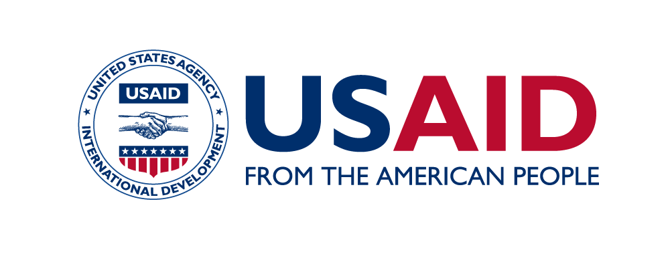
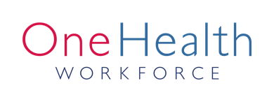
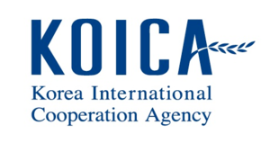

SEAOHUN 2019 Engaging Intergovernmental Organization:
Application form (sponsored participants)

Thank you for your interest in the SEAOHUN 2019 EIO program. This application form is intended for applicants who wish to be sponsored to participate in the SEAOHUN 2019 EIO program. Please read instruction in each of the following sections carefully and provide information accordingly. Please submit complete application package by the end of 8 March 2019 to arusa@seaohun.org.

Personal Information
Please provide your personal information in the fields provided.

Title:
Name (first, middle, last name):
Age:
Nationality (please select by marking “X”)
- Malaysia
- Vietnam
- Indonesia
- Thailand
- Cambodia
- Laos
- Myanmar
Address:
Telephone:
Email:

Statement of Purpose
Please describe your motivation in participating in the SEAOHUN EIO Program. What you would like to learn during the program and how you intend to apply the acquired knowledge upon your return to your institution. (500 words maximum)

Supporting Documents
Please submit (a) participation approval form signed by supervisor and (b) curriculum vitae with this application to arusa@seaohun.org. The application will be complete upon the receipt of the abovementioned documents.

I hereby certify that the provided information is true and complete to the best of my knowledge.

Signature_____________________
(Name)
Date________________________

