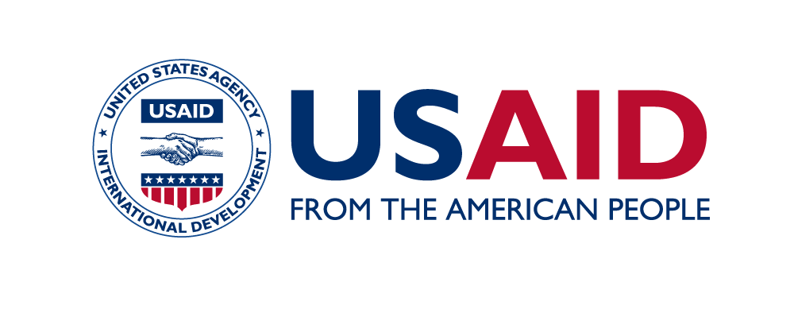
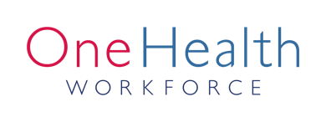
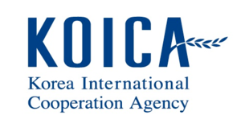

SEAOHUN 2019 Engaging Intergovernmental Organization

Adapted from the global Engaging Intergovernmental Organization (EIO), the Southeast Asia One Health University Network (SEAOHUN)’s EIO program is a platform for mid-career and senior professionals to foster their network and collaboration. This intensive professional development program allows professionals, experts and key regional leaders to meet, discuss and seed collaborations on their projects related to One Health or other global challenges.

SEAOHUN 2019 EIO program will be held in Bangkok, Thailand during 29 April – 3 May 2019. The program features sessions with the following potential organizations:

- USAID Regional Development Mission for Asia (USAID RDMA)
- Food and Agriculture Organization Regional of the United Nations Office for Asia and the Pacific (FAO-RAP)
- World Organization for Animal Health Sub-Regional Representative for South East Asia (OIE SRR-SEA)
- World Health Organization (WHO) Thailand
- Thailand Ministry of Public Health – United States CDC Collaboration (TUC)
- Thai Coordinating Unit for One Health (Thai CUOH)
- The Mekong Basin Disease Surveillance (MBDS) Secretariat
- Emergency Operation Center (EOC), Ministry of Public Health Thailand
- World Bank Group
- Fleming Fund Management Agent

The SEAOHUN 2019 EIO program welcomes up to 40 participants (30 sponsored and 10 self-funded). Sponsored participants must submit application with supporting documents and meet the following criteria:
- Nationality from SEAOHUN member and expansion countries (Indonesia, Malaysia, Thailand, Vietnam, Cambodia, Lao PDR, and Myanmar).
- Be mid to senior One Health-related professionals aged 35 and older from universities, academic institutes and government.
- Fluent in English.
- Able to participate fully in the program.

Applicants who are willing to receive the award must submit the following document by the end of 22 February 2019
- Application form (click to download)
- Participation approval form signed by supervisor (click to download)
- Curriculum vitae

Self-funded participants must apply by submitting the following documents by the end of 8 March 2019.
- Application form for self-funded participants (click to download)
- Curriculum vitae
Registration fee for self-funded participants is USD 600 inclusive of lunch, breaks, dinner, transport, field trip, materials, fees for management and speakers for the entire program.

Application package and inquiries must be submitted to arusa@seaohun.org.

Provisional Program

Date | Activities
Monday, 29 April 2019 | Morning:  - Welcoming and orientation  - Participants’ presentation  - Team building activity  Afternoon:  Visit to United States Agency for International Development Regional Development Mission for Asia (USAID RDMA)
Tuesday, 30 April 2019 | Morning:  - Presentation by World Organisation for Animal Health Regional Representation for Asia and the Pacific (OIE SRR-SEA)  - Presentation by Charoen Pokpand Group  Afternoon:  Visit to Food and Agriculture Organization fo the United Nations Regional Office for Asia and the Pacific (FAO-RAP)
Wednesday, 1 May 2019 | Visit to Thailand’s Ministry of Public Health:  - World Health Organization (WHO) Thailand  - Thailand Ministry of Public Health and United States Centers for Disease Control and Prevention Collaboration (TUC)  - Thai Coordinating Unit for One Health (Thai CUOH)  - Mekong Basin Disease Surveillance  - Emergency Operation Center (EOC)
Thursday, 2 May 2019 | Field trip
Friday, 3 May 2019 | Morning:  - Presentation by World Bank Group  - Presentation by Fleming Fund Management Agent  Afternoon:  Wrap up and closing

