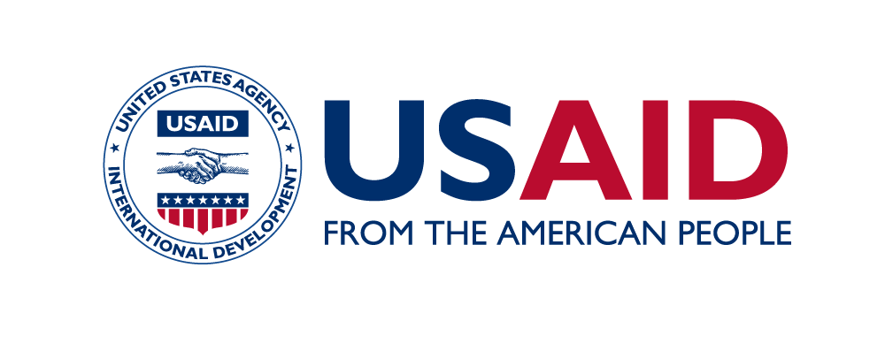
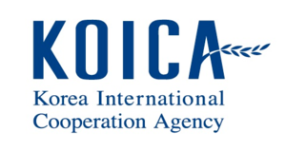

SEAOHUN 2019 Engaging Intergovernmental Organization:
Application form (self-funded participants)

Thank you for your interest in the SEAOHUN 2019 EIO program. This application form is intended for applicants who wish to pay to participate in the SEAOHUN 2019 EIO program. Registration fee of USD 600 is inclusive of lunch, breaks, dinner, transport, field trip, materials, fees for management and speakers for the entire program.

Please read instruction in each of the following sections carefully and provide information accordingly. Please submit complete application package by the end of 8 March 2019 to arusa@seaohun.org.

Personal Information
Please provide your personal information in the fields provided.

Title:
Name (first, middle, last name):
Age:
Nationality:
Address:
Telephone:
Email:

Supporting Documents
Please submit curriculum vitae with this application to arusa@seaohun.org.

Participation confirmation
SEAOHUN will confirm your participation and instruct registration fee payment before 15 March 2019.

I hereby certify that the provided information is true and complete to the best of my knowledge.

Signature_____________________
(Name)
Date________________________

